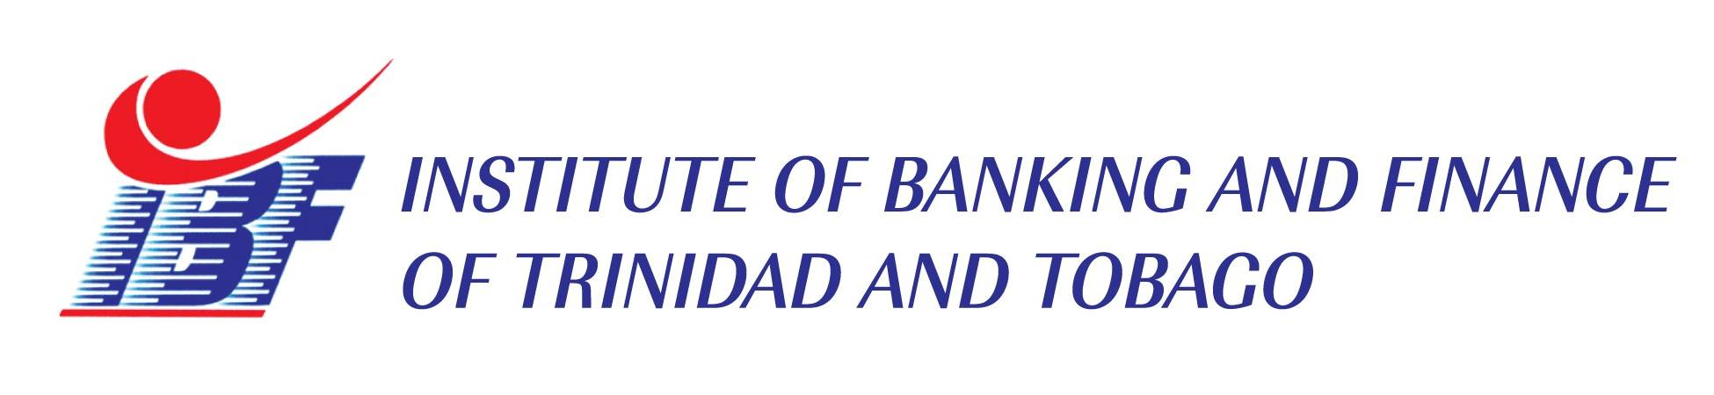
CPD HOURS: 2.75
WORKSHOP REGISTRATION FORM
Anti-Money Laundering/CFT for Non-Profit Organizations
Half Day online training workshop
Delivery method: MS Teams
Date: JULY 25TH, 2024
Time: 8:30 a.m. to 11:30 a.m.
Cost: $850.00 plus VAT = $956.25

PARTICIPANT DETAILS

NAME | JOB TITLE | EMAIL ADDRESS
COMPANY INFORMATION
Company Name:
Address:

Telephone: | Fax: | Email:
Contact Person:
Authorized Signature and stamp:

Please complete and return to us via email at: marketing@ibf.org.tt or info@ibf.org.tt by no later than July 22nd , 2024. Payment and Cancellation Policy: To confirm booking a 10% non-refundable payment is due seven (7) days after submission of registration form. Call 321-9330 for any queries.

