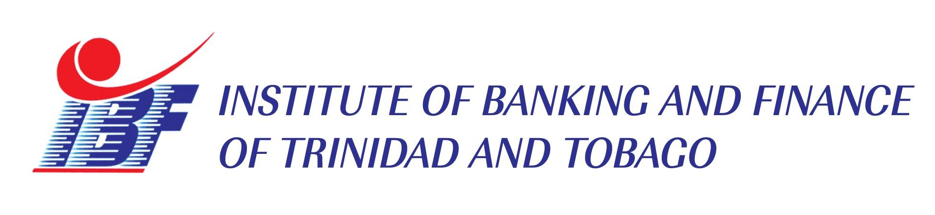
CPD HOURS: 12
WORKSHOP REGISTRATION FORM
A-Z IN MORTGAGE FINANCING
TWO (2) day training workshop
Venue: Institute of Banking and Finance of T & T Address: Level 1, Invader’s Bay Towers,
Off Audrey Jeffers Highway,
Port of Spain
Date: JULY 16TH & 17TH, 2024
Time: 8:30 a.m. to 4:00 p.m.
Cost: $3,200.00 plus VAT = $3,600.00

PARTICIPANT DETAILS

NAME | JOB TITLE | EMAIL ADDRESS
COMPANY INFORMATION
Company Name:
Address:

Telephone: | Fax: | Email:
Contact Person:
Authorized Signature and stamp:

Please complete and return to us via email at: marketing@ibf.org.tt or info@ibf.org.tt by no later than July 8th, 2024. Payment and Cancellation Policy: To confirm booking a 10% non-refundable payment is due seven (7) days after submission of registration form. Call 321-9330 for any queries.

